  
  
**SIES (Nerul) College of Arts, Science and Commerce**  
**NAAC Re-Accredited ‘A’ Grade**

**Sri Chandrasekarendra Saraswathy Vidyapuram,**  
**Plot 1-C, Sector V, Nerul, Navi Mumbai-400 706**

**PROJECT REPORT**

**ON**

**Paws ‘N’ Tails Online Pet Website System**

**SUBMITTED**

**TO**

**UNIVERSITY OF MUMBAI**

**BY**

**Vinay Iyer**

**(TYBSc.Computer Science)**

**2016-17**



**SIES (Nerul) College Of Arts, Science and Commerce**  
**NAAC Re-Accredited ‘A’ Grade**

**Sri Chandrasekarendra Saraswathy Vidyapuram,**  
**Plot 1-C, Sector V, Nerul, Navi Mumbai-400 706**

**Certificate**

This is to certify that the project entitled “**Paws ‘N’ Tails Online Pet Care System”** developed in JAVA using JSP and Servlets is successfully completed by Mr. Vinay Iyer of Third Year Bachelor of Science (Computer Science) as per the requirement of University of Mumbai in partial fulfilment for the completion of Degree of Bachelor of Science (Computer Science). It is also to certify that this is the original work of the candidate done during the academic year 2016-2017.

Seat No:

Date of Submission:

Prof. Padmaleela Damaraju Prof. Alpana Pandey Prof. Padmaleela Damaraju  
(Project Guide) (Documentation in charge) (Coordinator)

Date: _______ Date: _______ Date: _______

External Examiner Prof. Koel Roychoudhary

Date: _______ (College Seal) (Principal)

**PREFACE**

It is great opportunity for me to present this project on a very interesting topic i.e. “Paws ‘n’ Tails Online Pet Care System” as the Final Year Project.

This report consists of all the basic knowledge needed for software development along with various diagrams and charts.

I have taken complete care to include almost all modules related to the topic and put it up in an interesting and an attractive format.

This system provides features of low rate of data inconsistency.

We involved in this project have worked with commitment right from the initialization of the project and continuing all the way till its completion.

Review of the project is an unending process; it may contain errors, as there is always a scope for improvements.

The content of the project is true and verified and aims to give a simple and clear understanding of the design and implementation of the software.

**ACKNOWLEDGEMENT**

I would like to acknowledge and extend my heartfelt gratitude to the following people who have made the completion of my project possible.

I extend my heartfelt gratitude and thanks to Padmaleela Maam and Alpana Maam for providing me excellent guidance to work on this project and for their understanding and assistance for providing all the necessary information needed for completing the project.

I would also like to acknowledge all the staffs for providing a helping hand to us in times of queries & problems. The Project is a result of the efforts of all the peoples who are associated with the Project directly or indirectly, who helped us to successfully complete the Project within the specified time frame.

Thanks to all my teachers, who were a part of the project in numerous ways and for the help and inspiration they extended to me and for providing the needed motivation.

I would like to Thanks our colleagues for keeping our Sprits High while preparing the Project. Because of their Diligent & Hard Work, we wouldn’t have been able to complete the Project within the given Time Frame.

With all Respects & Gratitude, we would like to Thanks to all the people, who have helped in the Development of the Project.

By,

**Vinay Iyer**

**INDEX**

|  |  |
| --- | --- |
| **Chapters No.** | **Contents** |
| **01** | **Preliminary Investigation**   * Organizational Overview * Description of System * Limitation of present system * Proposed system and its advantages * Feasibility Study * Stakeholders * Technologies Used * Gantt chart |
| **02/** | **System Analysis**   * Fact Finding Techniques(Interview, Questionnaire, Record View, Observation) * Event Table * Use case Diagram & use case Description * ERD * Activity Diagram * Class Diagram * Object Diagram * Sequence Diagram/Collaboration Diagram * State Diagram |
| **03** | **System Design**   * Converting ERD to Tables * Design Class Diagram * Component Diagram * Package Diagram * Deployment Diagram |
| **04** | **System Coding**   * Menu Tree * List of tables with attributes and constraints * Validations * Test Cases, Test Data and Test Results * Screen Layouts & Report Layouts * Program Listing |
| **05** | **Future Enhancements** |
| **06** | **References and Bibliography** |

**Phase Completion Table**

|  |  |  |  |  |
| --- | --- | --- | --- | --- |
| **Phase Title** | **Starting Date** | **Expected Date of Completion** | **Actual Time of Completion** | **Remarks** |
| **1. Preliminary**  **Investigation** | **19/11/16** | **26/11/16** | **28/11/16** |  |
| 1.2 Introduction |  | 19/11/16 | 19/11/16 |  |
| 1.2 Existing system & its  Disadvantages |  | 21/11/16 | 21/11/16 |  |
| 1.3 Proposed System and its advantages |  | 22/11/16 | 22/11/16 |  |
| 1.4 Feasibility study |  | 23/11/16 | 24/11/16 |  |
| 1.5 Components |  | 25/11/16 | 25/11/16 |  |
| 1.6 Gantt chart |  | 25/11/16 | 28/11/16 |  |
| **2. System Analysis** | **03/12/16** | **14/12/16** | **14/12/16** |  |
| 2.1 Event Table |  | 03/12/16 | 03/12/16 |  |
| 2.2 Use Case Diagram |  | 05/12/16 | 05/12/16 |  |
| 2.3 ERD |  | 06/12/16 | 06/12/16 |  |
|  |
| 2.4 Activity Diagram |  | 07/12/16 | 07/12/16 |  |
| 2.5 Class Diagram |  | 08/12/16 | 08/12/16 |  |
|  |
| 2.6 Object Diagram |  | 09/12/16 | 09/12/16 |  |
| 2.7 Sequence Diagram |  | 14/12/16 | 14/12/16 |  |

|  |  |  |  |  |
| --- | --- | --- | --- | --- |
| **3. System Design** | **21/12/16** | **09/01/17** | **09/01/17** |  |
| 3.1 Converting ERD to Table |  | 21/12/16 | 21/12/16 |  |
|  |
| 3.2 Design Class Diagram |  | 03/01/17 | 03/01/17 |  |
| 3.3 Component Diagram |  | 05/01/17 | 05/01/17 |  |
| 3.4 Deployment Diagram |  | **07/01/17** | **07/01/17** |  |
| 3.5 Package Diagram |  | **09/01/17** | **09/01/17** |  |
| **4 System Coding** | **16/01/17** | **13/02/17** | **16/02/17** |  |
| 4.1 Menu Tree/Site Map |  | 20/01/17 | 20/01/17 |  |
| 4.2 Listing of tables with Attribute and Constraints |  | 23/01/17 | 23/01/17 |  |
| 4.3 Validations |  | 26/01/17 | 26/01/17 |  |
| 4.4 Screen Layout & Report Layout |  | 13/02/16 | 15/02/17 |  |
| 4.5 Program Listing |  | 15/02/17 | 16/02/17 |  |
|  |
| **5 System implement uploading** | **20/02/17** | **20/02/17** | **20/02/17** |  |
| **6 Project Report Submission** | **25/02/17** | **01/03/17** | **01/03/17** |  |
|  |
| 6.1 Future Enhancement |  | 25/02/17 | 25/02/17 |  |
| 6.2 Reference& by Bibliography |  | 01/03/17 | 01/03/17 |  |

Preliminary Investigation

**I. PRELIMINARY INVESTIGATION**

➢ PRIMARY INTRODUCTION

➢ DESCRIPTION OF EXISTING SYSTEM

➢ LIMITATIONS OF PRESENT SYSTEM

➢ PROPOSED SYSTEM AND ITS ADVANTAGES

➢ TECHNOLOGIES USED

➢ STAKEHOLDERS

➢ FEASIBILITY STUDY

➢ GANTT CHART

##### PRIMARY INTRODUCTION

**About Paws ‘N’ Tails:**

The purpose of designing an online system is that it facilitates the ease of ordering pets through an efficient online Pet Care System. There shall be a page for registration, login for the user respectively. First time users shall have to fill out a form specifying their respective details, then register on to a portal. Regular users can login to the system with their respective username and password. The system shall be equipped with the main transactions between the client and server such as Purchase Pets and mainly Accessories for the client’s respective pet.

The Online system would give advantages of determining whether a pet is available or not by a quick search and gathering all details of that pet. The Online System would easily understandable, have a clear layout and be easily presentable.

The functionality of the website shall be eased with the help of Java for back end registration for primary transactions between the user and server. Separately a database shall accommodate all necessary pets, along with their respective details such as make, breed, domesticity and availability. These details shall be fetched from the database back to the user when the user completes a form for purchase or rental. This is the same for other transactions.

**Description of Existing System**

The main disadvantage of the current system is that clients physically have to take to the trouble of going to the shop and purchase the pets of their respective choice. This may cause a problem when a client goes to the pet shop and may search for the respective pet of his choice and it may not be available, due to the size, wide variety of pets. Also the owner may forget to mention some important characteristic about the pet whether it is trained or not, suited for domesticity.

This document will propose all features and procedures to develop the system.

This document specially containing details about objectives, scope limitation, process model, primary requirements, team development, possible project risks, project schedule, and finally monitoring and reporting mechanisms.

One of the biggest features of the system is that it reduces manpower and labour. The System introduces a database to store all user records where the System provides us with the correct output automatically and correctly.

Also there is less chance of errors occurring in this case.

As the world is going with the technology it is important for us to also go with it. Using technology by local tiffin service provider makes the user attractive towards this Service.

**Limitations of Existing System**

1. It may be time consuming to purchase a pet through a local service/order.
2. Pet Shop employees shall have to keep a record of all users’ pet orders and their demands which is time consuming.
3. The records are stored manually so there is chance of loss of data.
4. Less exposure to technologically less efficient people.
5. Shipping orders can be a detriment if the item to be ordered is not in stock.

**Proposed System and its Advantages**

This online website enables the users to register through a form, select the pet/accessory from a products page and after careful consideration choose to place an order of his/her particular choice. By just selecting the pet that the user would want to have, the results of this order shall directly be placed after selecting the pet/accessory from the and a response message thanking the user for the particular order shall be delivered back in a feedback form.

The benefit, as shall be stated once again, reduces time from ordering manually by going to a store and placing order when one can place an order online. The user will be given a username and a password, or guest user also can order. Registered users shall get exciting offers and discounts based on their purchases.

Manual system involves paper work in the form of maintaining various files and manuals. This can be a risky and tedious process. The solution to this is to include a framework that shows how to apply Internet technology progressively as skills and confidence grow.

The project demonstrates the route from adapting materials to developing an online environment which would benefit both the developer and user end. So this software helps them to register, place orders and save time whenever they want without calling the employee or shopkeeper again.

One disadvantage is that customers are not as much as involved in it.

**The objectives of this project are:**

To order pets/accessories online  
• To make it convenient for people who have limited time  
• Cost reduction  
• Reduced paper work  
• Computerized Order and billing system

**Scope of the Project:**

1. It can be used by any user to place orders online.
2. Storing information about different types of orders placed.
3. The whole management could be controlled through admin interface through which the clients and host system could be managed from anywhere.
4. This system also maintains the information about the order price.
5. Storing information about the register user that deals with admin.

**Methodology Adopted**

1. Initially, I collected all the information which was to be stored.
2. Then I studied the configuration of the database and noted the difficulty of the system, which motivated them to have new system.
3. Then analyzed the format of the report generated by that system.
4. The methodology adopted for developing the system is the Waterfall Model,

**Reasons for Choosing the Topic**

A rapidly growing field that allows users to place purchase of pets/accessories online promises to develop technology and innovation in a system that was once considered to be a manual one in an exciting way.

If this system shows signs of progress and development, it can go a long way in bringing awareness on ordering/purchasing pets online.

**FEASABILITY STUDY**

### The feasibility study is divided into three different parts:

### Operational Feasibility

### Technical Feasibility

### Economic Feasibility

### OPERATIONAL FEASABILITY:

Managing and keeping records of all Customers and the entire system in digital format i.e. in computers. As it is online the customer doesn’t have visit the local shop so they can place the orders online. Tiffin service provider doesn’t have to manually keep a record of all the food ordered by the customer and that work is very easy.

An online pet service doesn’t have to manually calculate the amount of money to be paid by the customer after ordering the pet as it is automatically done in the software. Records are maintained in computers so there are less chances of damage and loss of data. This gives more exposure to people in the world of technology.

### TECHNICAL FEASABILITY:

### Technical feasibility centers around the existing computer system (HW/SW) and to what extends it can support the proposed additions. Support for the software is readily available. There is no need for a technical person to supervise the working of the Website. The proposed Website is user friendly. There is just one operator needed to use analyses the website, rather than so many people needed to keep track of the documents.

### ECONOMIC FEASABILITY

### The proposed system is economically feasible. As the hardware and the software used are already available, there is no need to buy a new copy of the software, thus maintaining the budget.

**STAKEHOLDERS**

In each and every circumstance the user must be listed as authorized to use Paws ‘n’ Tails with a unique surname and password after registering as a customer. On every login, they see the page of products and can view accessories. The following section outlines the nature of the provision within Paws ‘n’ Tails for each of the registered customers.

1. Users

* Users are provided with the option of registering themselves with a username, email and password and continue to have ownership of that data through editing at any time whatsoever.
* In the module, once the user logs in, they shall see all the listed items in the page of products and can view the accessories accordingly.
* They can view a description of their items to get a look and feel of their respective items.
* They can manage all of this information and add items to their shopping cart.
* They can add and delete items from their shopping cart.
* They have an option of resetting their password.
* Also the date of delivery is chosen as an exclusive option for the customers who wish to enter the earliest date of delivery of their respective product from the payment form.

1. Manager

* Manager of the website can view all the payment details the customers have registered within the system.
* Manager can also view the reports of the created pet, accessory and delete an item of their choice in the system depending on the customer or website’s need for system growth.
* Manager can view the feedback of all the registered customers.
* The manager can also view lists of all the orders taken place in the system.

**TECHNOLOGIES USED**

Hardware Requirement

|  |  |
| --- | --- |
| Processor | Intel(R) Core™ i3, Pentium IV,  Dual Core,  Core 2 Duo or Higher |
| Operating System: | Windows |
| RAM: | 128MB Minimum |
| Hard Disk: | 100 GB and above |

Software Requirement

|  |  |
| --- | --- |
| Development technologies | JAVA |
| Operating system | Windows , Linux |
| Hardware | Desktop Computer |
| Front End | HTML, CSS, JAVASCRIPT |
| Back End | MySQL Server |
| Server Side Scripting | JSP and SERVLETS |

### GANTT CHART

|  |  |  |  |  |  |  |
| --- | --- | --- | --- | --- | --- | --- |
| **Task Name** | **Nov** | **Dec** | **Jan** | **Feb** | **March** | |
| |  | | --- | | **Preliminary Investigation** | |  |  |  |  |  | |
| Introduction |  |  |  |  |  | |
| Existing system and its disadvantages |  |  |  |  |  | |
| Proposed system and its advantages |  |  |  |  |  | |
| Feasibility study |  |  |  |  |  | |
| Components |  |  |  |  |  | |
| Gantt chart |  |  |  |  |  | |
| **System Analysis** |  |  |  |  |  | |
| Event table |  |  |  |  |  | |
| Use Case Diagram |  |  |  |  |  | |
| ER Diagram |  |  |  |  |  | |
| Activity Diagram |  |  |  |  |  | |
| Class Diagram |  |  |  |  | |  |
| Object diagram |  |  |  |  |  | |
| Sequence diagram |  |  |  |  |  | |
| **System Design** |  |  |  |  |  | |
| Convert ERD into Tables |  |  |  |  |  | |
| Component Diagram |  |  |  |  |  | |
| Deployment Diagram |  |  |  |  |  | |
| Package Diagram |  |  |  |  |  | |
| **System Coding** |  |  |  |  |  | |
| Menu Tree |  |  |  |  |  | |
| List of Tables with Attribute |  |  |  |  |  | |
| Validation |  |  |  |  |  | |
| Screen layout and report layout |  |  |  |  |  | |
| Program listing |  |  |  |  |  | |
| **System Implementation** |  |  |  |  |  | |
| **Project Report Submission** |  |  |  |  |  | |
| Future Enhancement |  |  |  |  |  | |
| References and bibliography |  |  |  |  |  | |

**actual time : expected date :**

**System Analysis**

**II. System Analysis**

* **FACT FINDING TECHNIQUES**
* **EVENT TABLE**
* **USE CASE**
* **ENTITY RELATIONSHIP DIAGRAM**
* **ACTIVITY DIAGRAM**
* **CLASS DIAGRAM**
* **OBJECT DIAGRAM**
* **SEQUENCE DIAGRAM**
* **STATE MACHINE DIAGRAM**

**FACT FINDING TECHNIQUES**

The following fact finding techniques were used during the analysis phase of the project:

1. **Onsite Observation:** Observations were done during the first interview with theManager of Paws ‘n’ Tails. It was very useful, helping me to understand how the management works and what are the roles of different members- the Customer, the Admin, the Employer and the warehouse worker.
2. **Review the existing Document:** The document reviewed were reports of service details, soft copies of mail attachment of lists of services offered to the customer.
3. **Interviews:** We mainly interviewed the Manager and co-ordinator responsible for leading and managing such a company.. Theinformation of the interviews was very important because it helped in the analysis of the current system and the construction of the UML diagrams. In the interview some objectives were considered such as,
   1. Determining the areas to be discovered.

2. Listing the facts were to be gathered.

3. Discovering new alternatives/solutions to the problems the current system is facing.

**Given below is a sample of Questionnaire that was asked during interview:**

1. How does the company of Paws ‘n’ Tails fare better when compared to the works of hosting the website online on computers?
2. What are services provided by the website to customers?
3. What types of companies usually hosts such websites?
4. What parameters you take into consideration while discussing about services?
5. What different types of records you need or you maintain?
6. How do you keep track of customers who are interested?
7. Why the need of updating the existing system?
8. How many customers avail of the service and what are the limitations?

**EVENT TABLE**

|  |  |  |  |  |  |
| --- | --- | --- | --- | --- | --- |
| **EVENT** | **TRIGGER** | **SOURCE** | **USE CASE** | **RESPONSE** | **DESTINATION** |
| User(New) registers | Register | User | Register new User | User(New) added | User / Admin |
| User logs in | Logs in | User | Log in new User | Welcome page is opened | User |
| User purchases Pets | Purchase Order | User | Confirms in new purchase of Pets | Purchase details of Pets sent back to user | User / Admin |
| User purchases Accessories | Purchases Accessories | User | Confirms purchase order of Accessories | Purchase details sent back | User / Admin |
| Change password | Change password | User /Admin | Change password | Password updated | User |
| Admin generates reports | Report generation | Admin | Generate Reports | Reports are generated and can be viewed | Admin |
| Deletes Purchase | Deleting purchase | User | delete order | Purchase deleted | Admin |

**USE CASE DIAGRAM**

The Use case diagram is used to identify the primary elements and processes that form the system. The primary elements are termed as "actors" and the processes are called "use cases." The Use case diagram shows which actors interact with each use case.

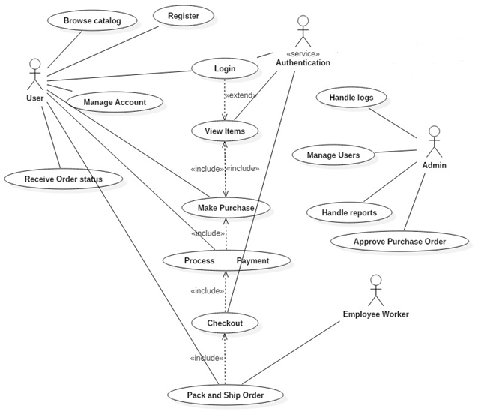

**ER Diagram**

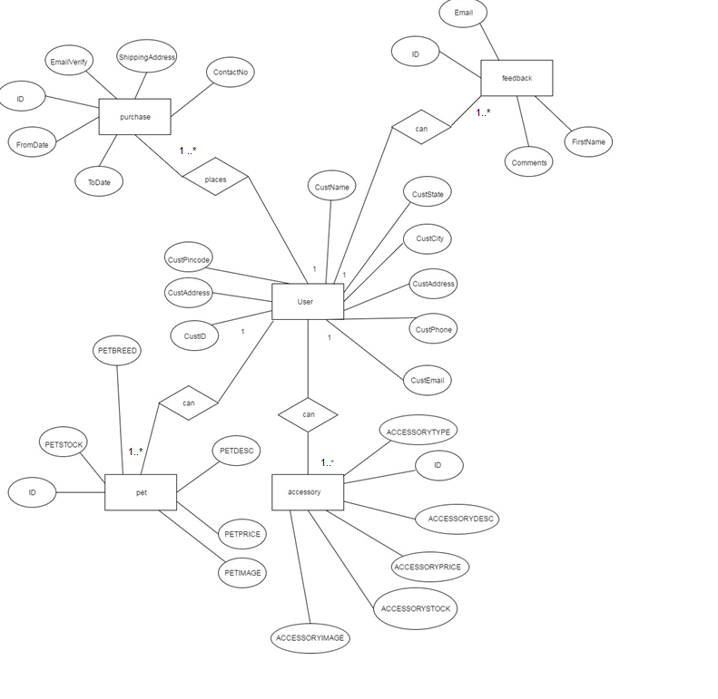

**Activity Diagram**

**Activity Diagram to Register**

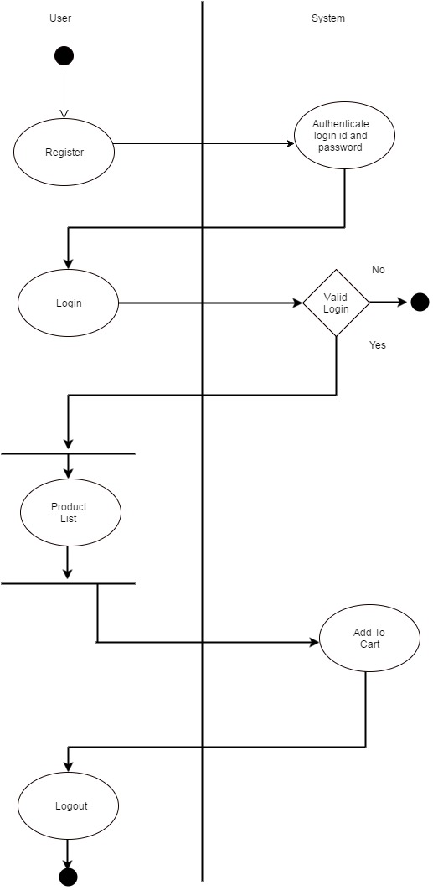

**Activity diagram of Purchase Pets/ Accessories**

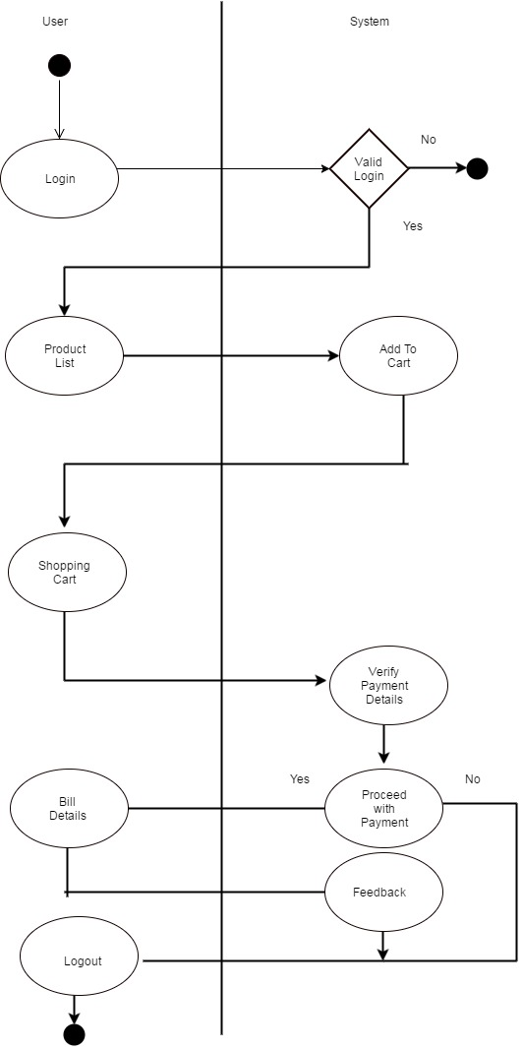

**Activity Diagram of Admin**

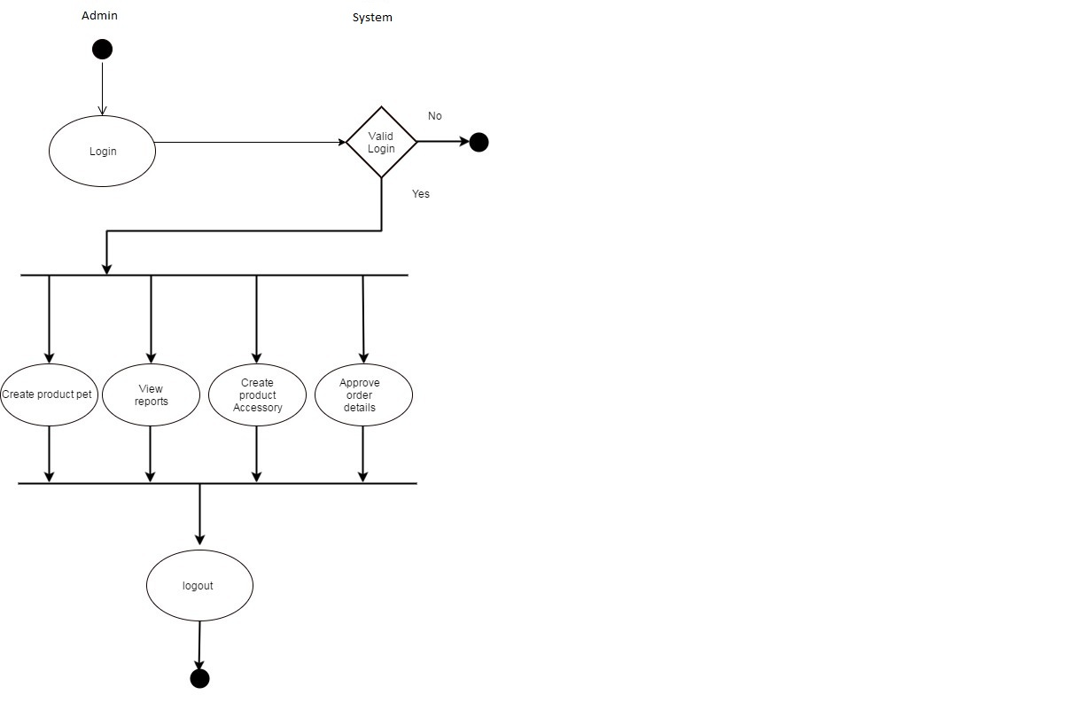

**CLASS DIAGRAM**

**Class diagram:** The class diagram is used to refine the use case diagram and define a detailed design of the system. The class diagram classifies the actors defined in the use case diagram into a set of interrelated classes. The relationship or association between the classes can be either an "is-a" or "has-a" relationship.

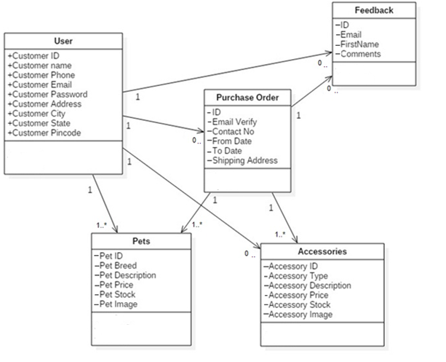

**OBJECT DIAGRAM**

The object diagram is a special kind of class diagram. An object is an instance of a class. This essentially means that an object represents the state of a class at a given point of time while the system is running. The object diagram captures the state of different classes in the system and their relationships or associations at a given point of time.

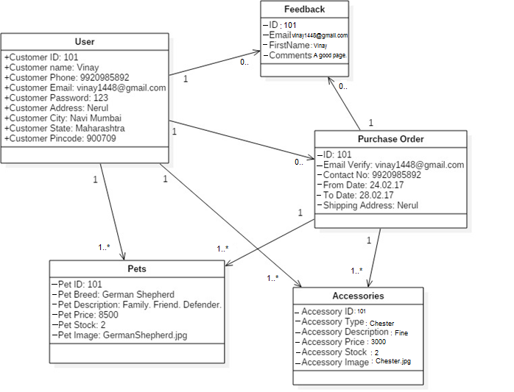

**SEQUENCE DIAGRAM**

**Sequence diagram:** A sequence diagram represents the interaction between different objects in the system. The important aspect of a sequence diagram is that it is time-ordered. This means that the exact sequence of the interactions between the objects is represented step by

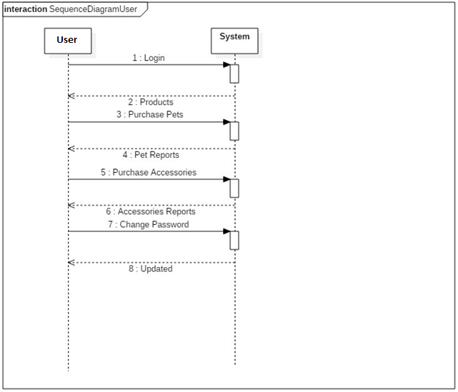

**SEQUENCE DIAGRAM**

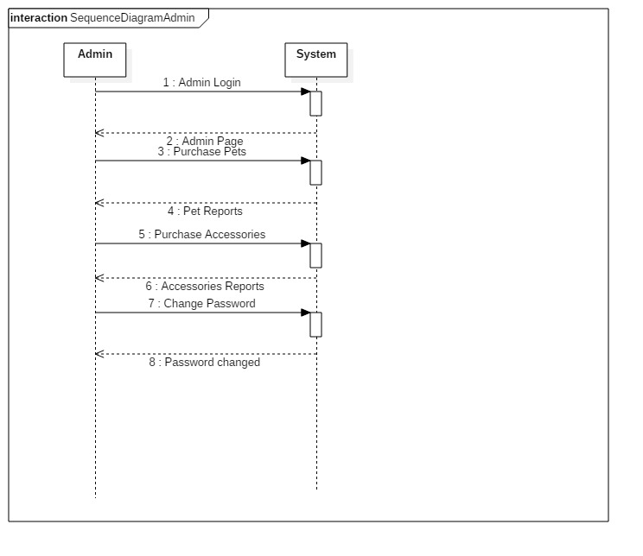

**State Chart Diagrams**

Order changed

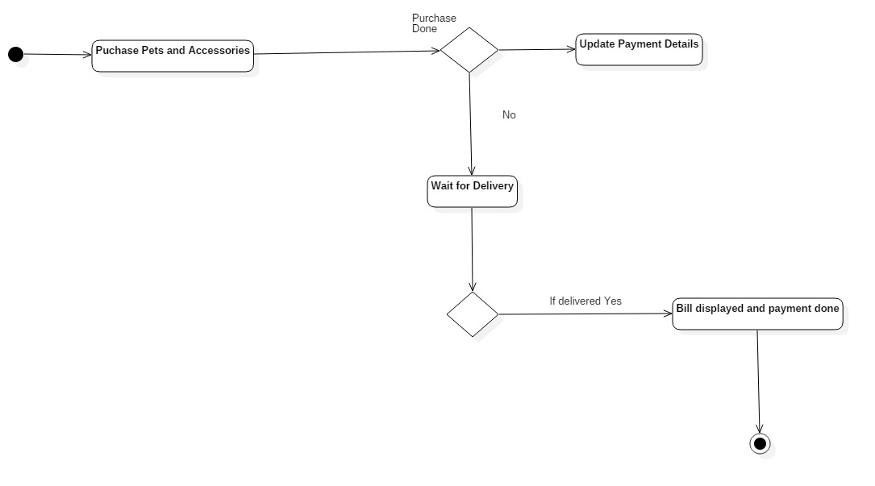

**System Design**

**III. System Design**

* CONVERTING ERD TO TABLES
* DESIGN CLASS DIAGRAM
* COMPONENT DIAGRAM
* PACKAGE DIAGRAM
* DEPLOYMENT DIAGRAM

**Converting ERD to Tables**:

|  |  |  |  |
| --- | --- | --- | --- |
| **Users:**   1. Customer ID 2. Customer Name 3. Customer Phone 4. Customer Email 5. Customer Password 6. Customer Address 7. Customer City 8. Customer State 9. Customer Pin Code |  | **Purchase Order:**   1. ID 2. Email Verify 3. Contact no 4. From Date 5. To Date 6. Shipping Address   **Pets:**   1. Pet ID 2. Pet Breed 3. Pet Description 4. Pet Price 5. Pet Stock 6. Pet Image |  |
| **Accessories**   1. Accessory ID 2. Accessory Type 3. Accessory Description 4. Accessory Price 5. Accessory Stock 6. Accessory Image |  | **Feedback**   1. ID 2. Email 3. FirstName 4. Comments |  |
|  |  |  |  |

**Design Class Diagram**

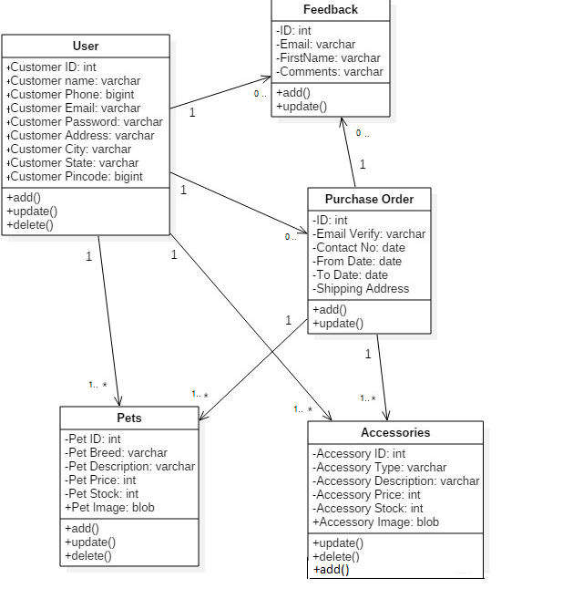

**Component Diagram**

The component diagram represents the high-level parts that make up the system. This diagram depicts, at a high level, what components form part of the system and how they are interrelated. A component diagram depicts the components called after the system has undergone the development or construction phase.

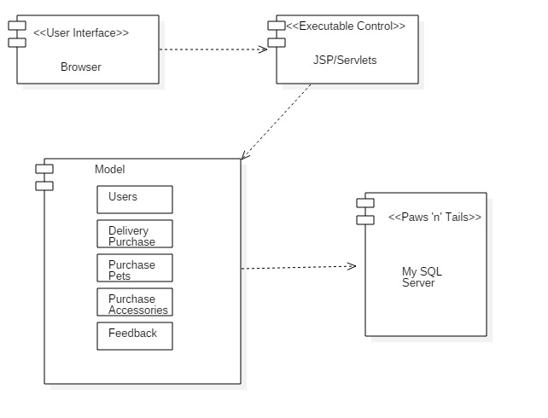

**PACKAGE DIAGRAM**

A package provides the ability to group together classes and/or interfaces that are either similar in nature or related. Grouping these design elements in a package element provides for better readability of class diagrams, especially complex class diagrams.

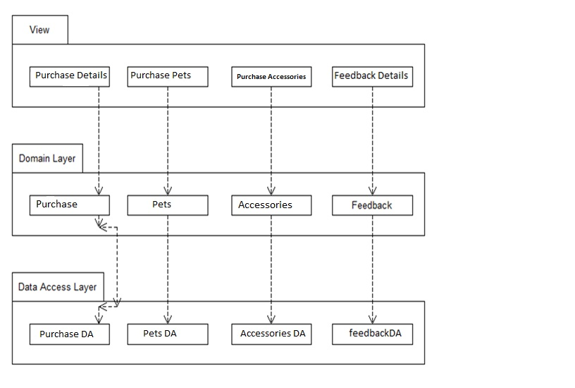

**DEPLOYMENT DIAGRAM**

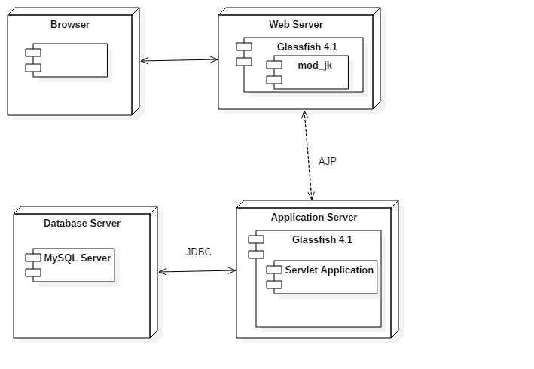

User

**System Coding**

**MENU TREE**

Paws ‘n’ Tails

User

Admin

Login

Register

Reports

Order Delivery

Order Delivery

Purchase Delivery

Pets Purchase

Pets Purchase

Accessories Purchase

Accessories Purchase

Feedback

Feedback

**List of tables with attributes and constraints**

**TABLE DESIGN:-**

**Table Name: accessory**

|  |  |
| --- | --- |
| **Column name** | **Data Type** |
| ID | int |
| AccessoryType | varchar(50) |
| AccessoryDesc | varchar(50) |
| AccessoryPrice | int |
| AccessoryDesc | Varchar(50) |
| AccessoryImage | Blob |

**Table Name: admn**

|  |  |
| --- | --- |
| **Column name** | **Data Type** |
| id | int |
| ADMINNAME | varchar(50) |
| ADMINEMAIL | varchar(50) |
| ADMINPASSWORD | Varchar(50) |

**Table Name: Feedback**

|  |  |
| --- | --- |
| **Column name** | **Data Type** |
| ID | int |
| Email | varchar(50) |
| FirstName | varchar(50) |
| Comments | varchar(50) |

**Table Name: Customers**

|  |  |
| --- | --- |
| **Column name** | **Data Type** |
| CustID | int |
| CustName | varchar(50) |
| CustPhone | varchar(50) |
| CustEmail | varchar(50) |
| CustPassword | varchar(50) |
| CustAddress | varchar(50) |
| CustCity | varchar(50) |
| CustState | varchar(50) |
| CustPincode | Varchar(50) |

**Table Name: orders**

|  |  |
| --- | --- |
| **Column name** | **Data Type** |
| ID | int |
| AMOUNT | int |
| CUSTADRS | varchar(50) |
| CUSTEMAIL | varchar(50) |
| CUSTNAME | varchar(50) |
| CUSTPHONE | varchar(50) |
| ORDERDATE | date |
| ORDERNUM | varchar(50) |

**Table Name: payment**

|  |  |
| --- | --- |
| **Column name** | **Data Type** |
| ID | int |
| EmailVerify | varchar(50) |
| ContactNo | varchar(50) |
| FromDate | date |
| ToDate | date |
| ShippingAddress | varchar(50) |

**Table Name: Pet**

|  |  |
| --- | --- |
| **Column name** | **Data Type** |
| ID | int |
| PETBREED | varchar(50) |
| PETDESC | varchar(50) |
| PETPRICE | varchar(50) |
| PETSTOCK | varchar(50) |
| PETIMAGE | blob |

**VALIDATIONS**

Validations made to the system enable us to get rid of number of frequently made mistakes. Validation prevents the further complications those may occur. It helps the new user to enter proper data into the system.

**Security at login form:**

For the security purpose the login form is used where the user should enter proper user name and password. If the user is entering wrong user name or password to the system, then system will get ended. It also provides different functionalities to the admin and user.

**Text boxes:**

While entering the information into the respective text boxes validations for numbers and alphabets (accordingly) are done. So that some text boxes are made to display only alphabetical value and some are made to display only numbers. Further if the text box is displaying mobile number then it should contain 10 digits.

**No Empty Field:**

While submitting the form no field is allowed to be null.

**Email Id:**

While entering the email id, the email id must follow standards of an email address.

Email id with null value or invalid format is not allowed.

**Phone Number:**

While entering the Phone number, the phone number must follow standards of phone number. Phone number with null value or invalid format is not allowed.

**SCREEN LAYOUTS**

**Home Page**

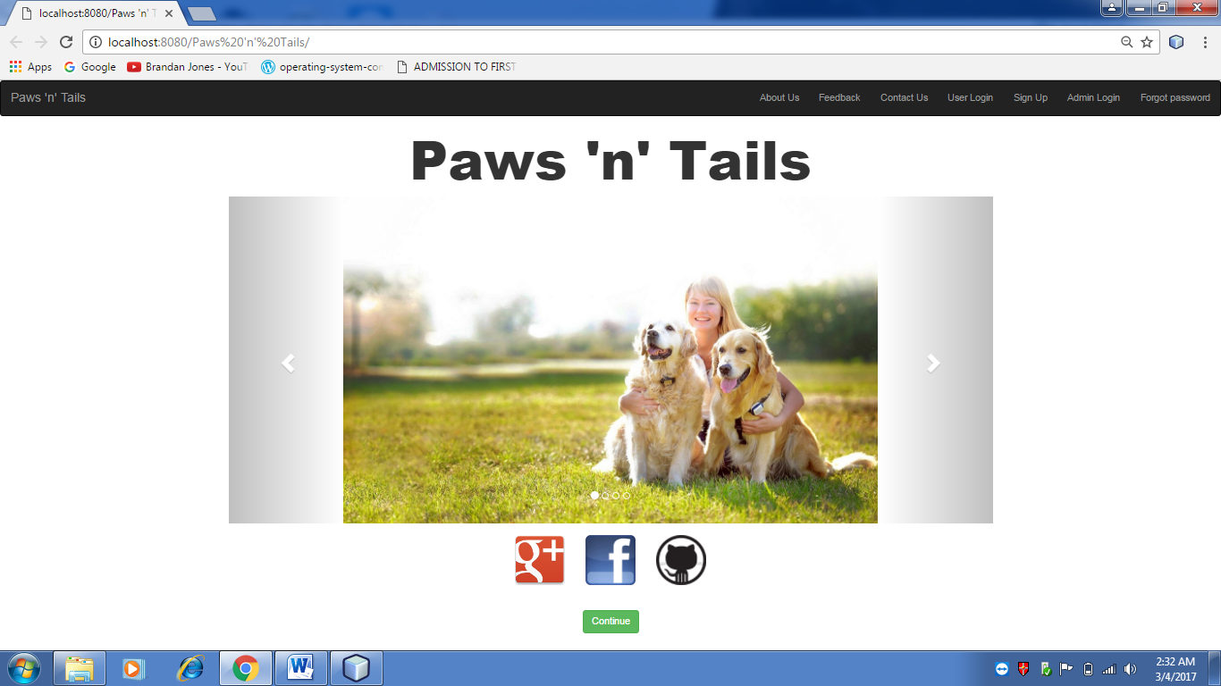

**Admin Console**

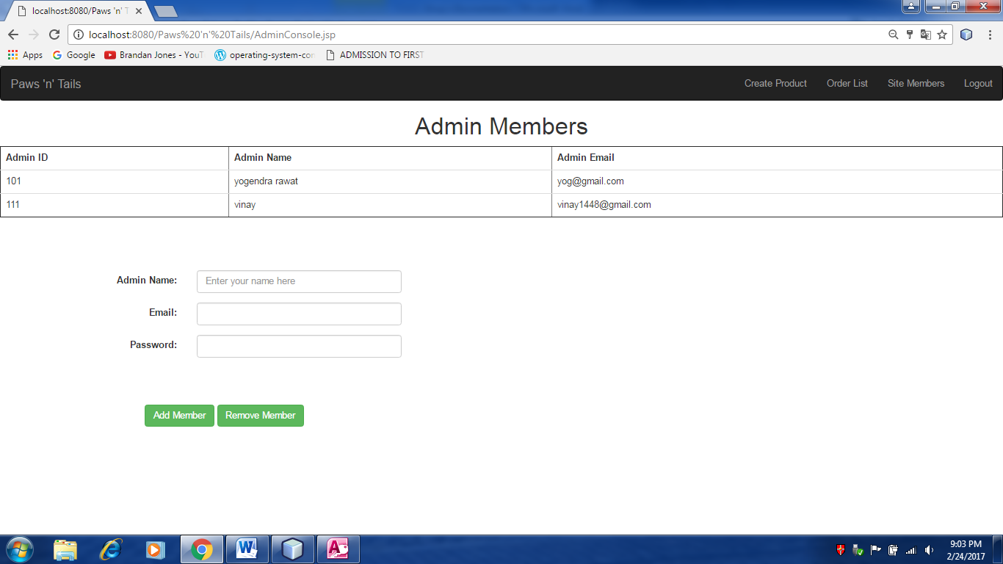

**CheckOut**

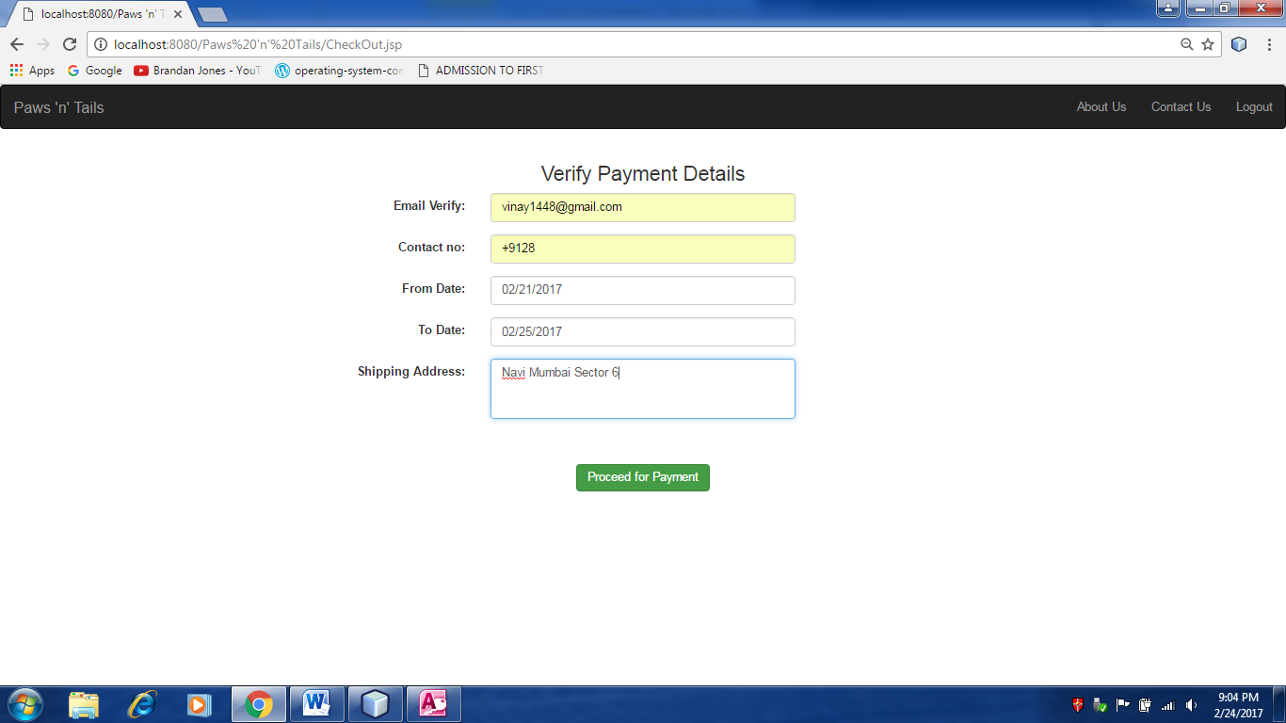

**About Us:**

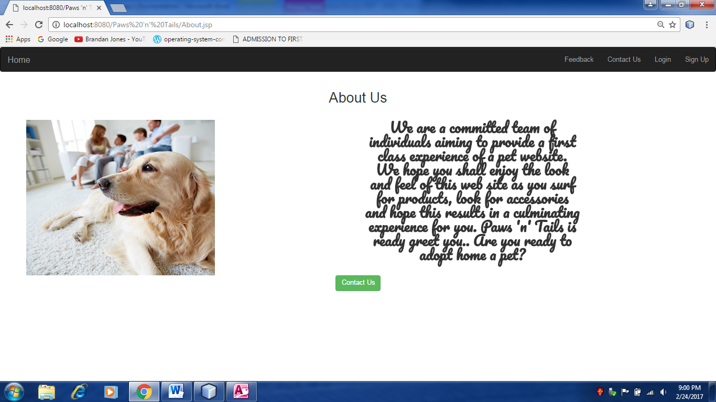

**Contact Us:**

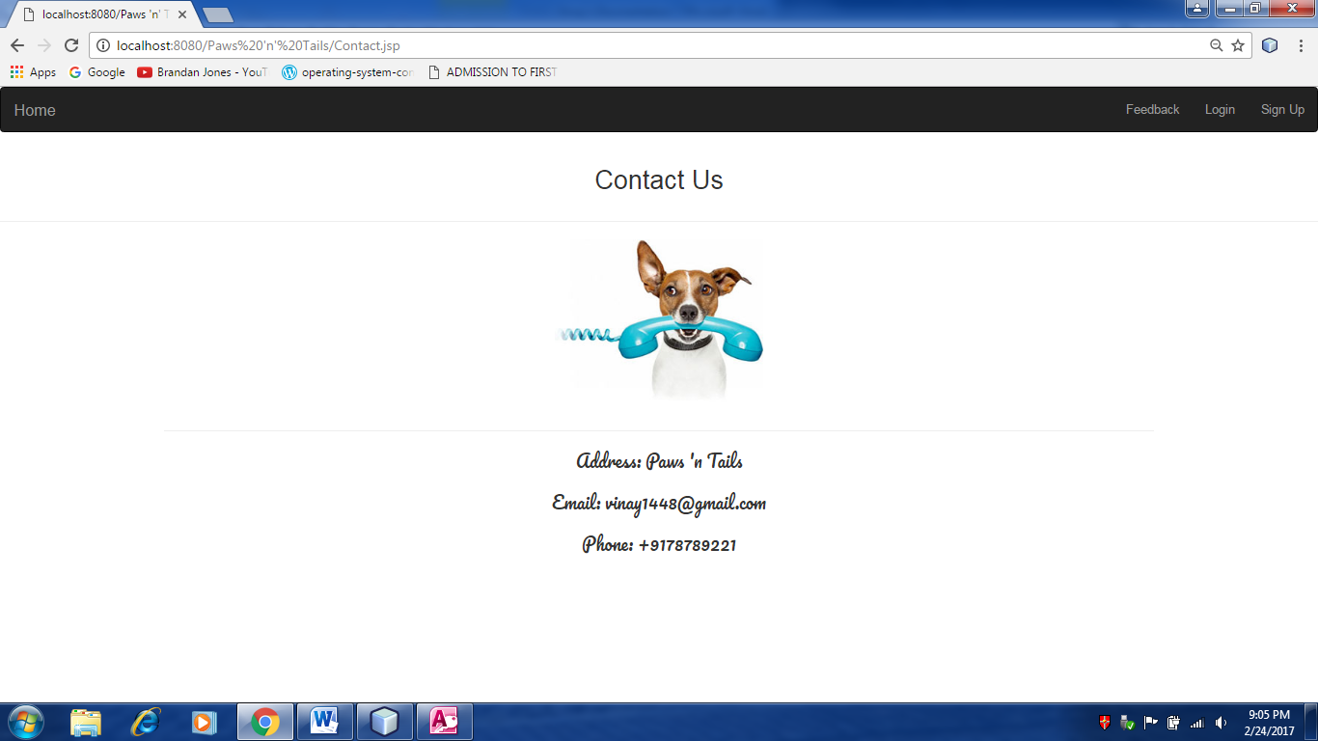

**Feedback:**

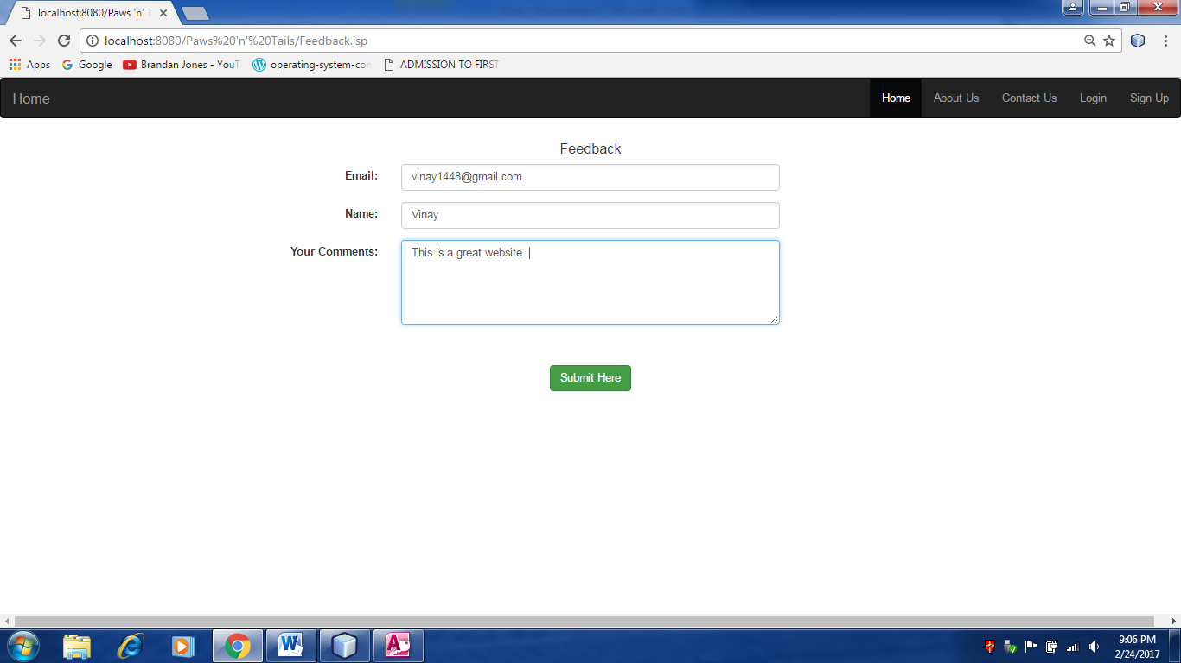

**OrderList**

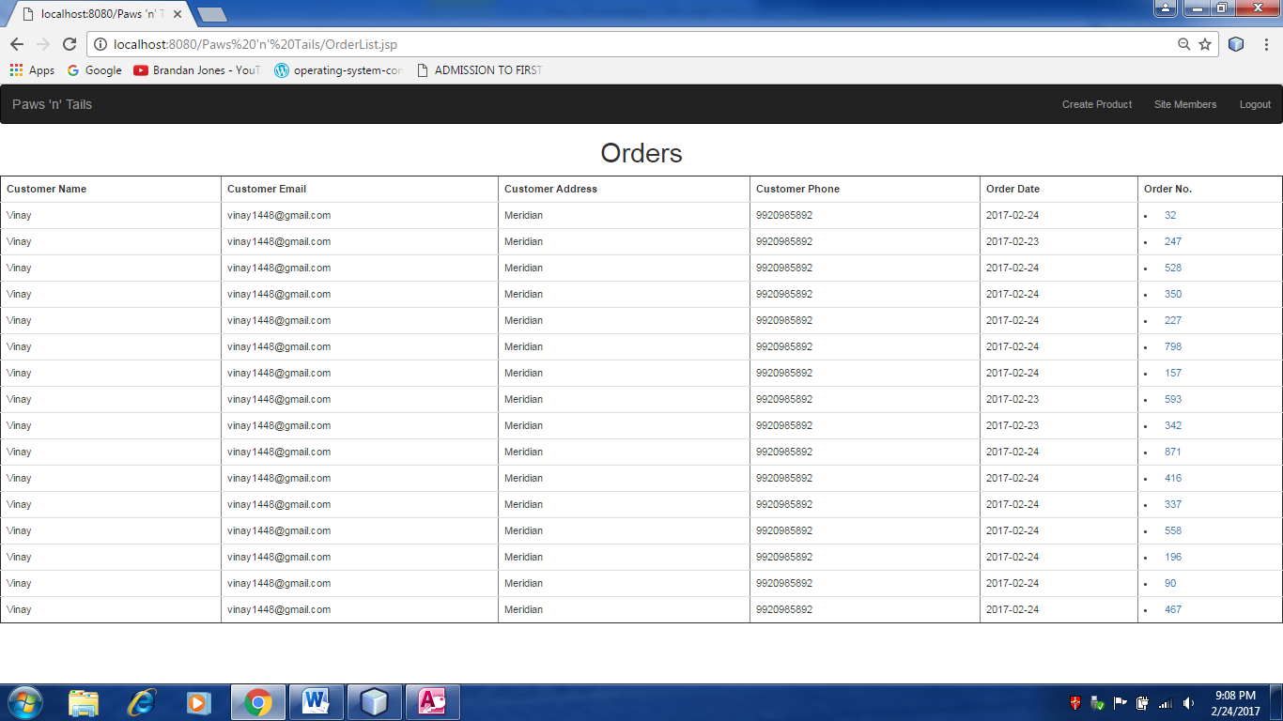

**ProductList**

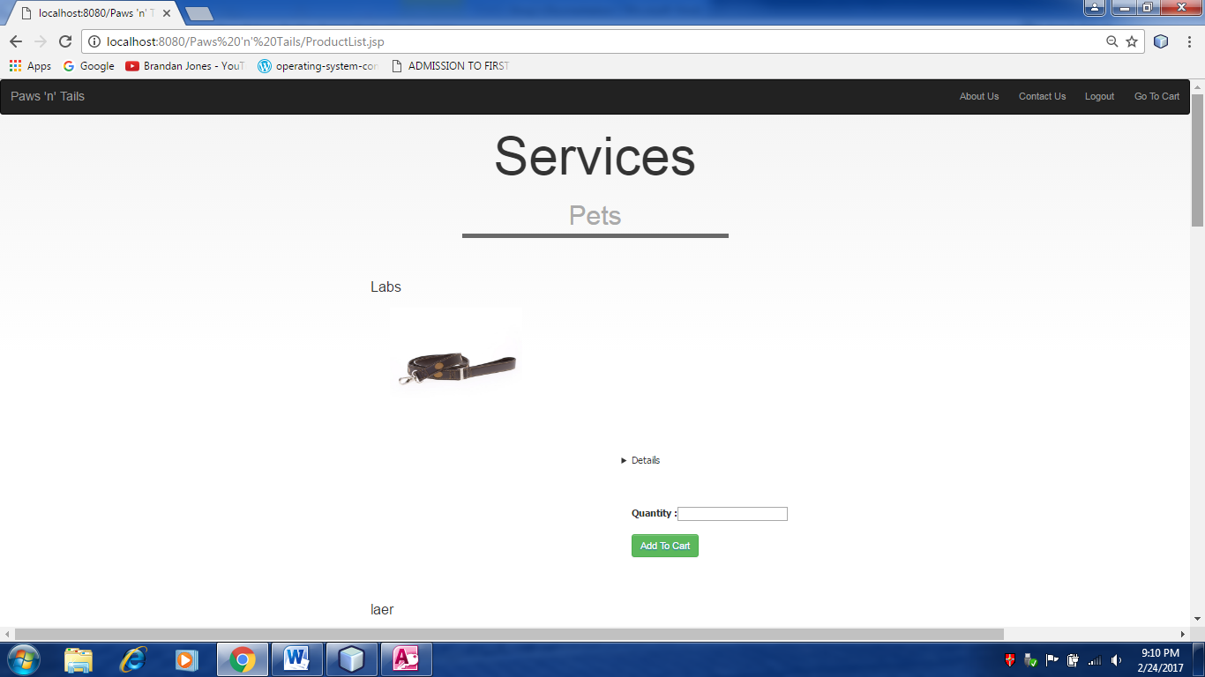

**ShoppingCart:**

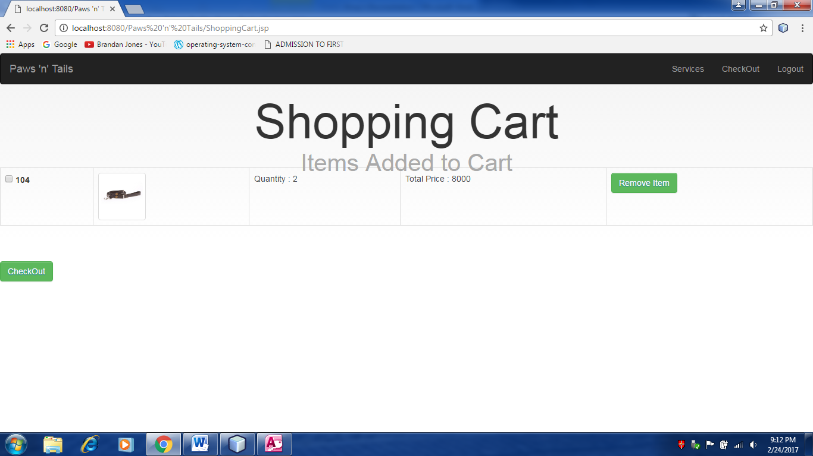

**Registration Page**

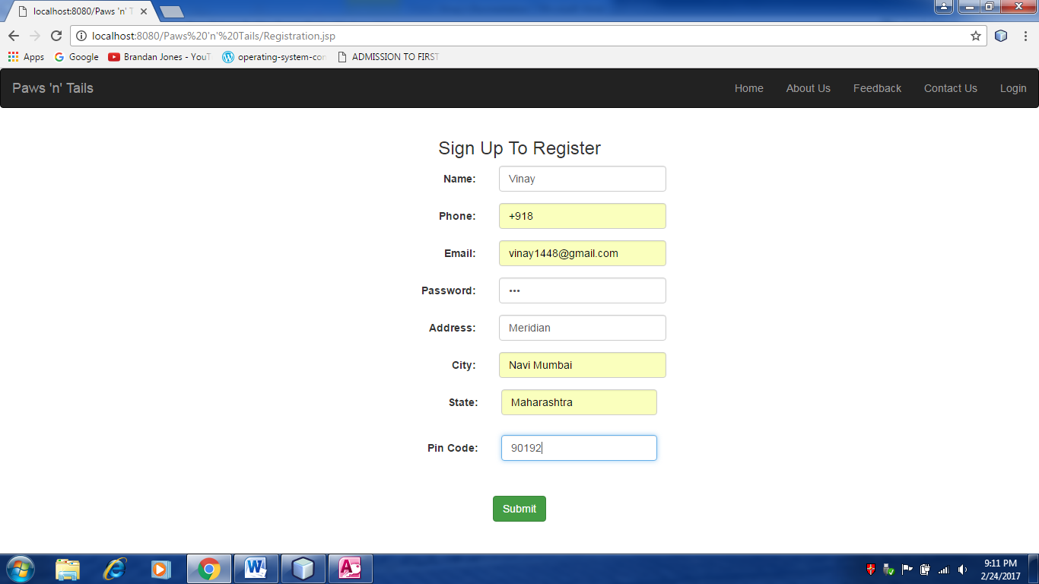

**Login:**

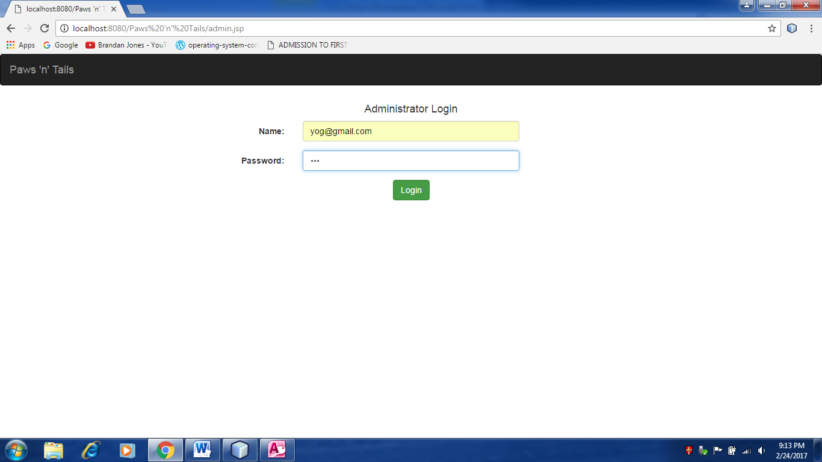

**CreateProduct**

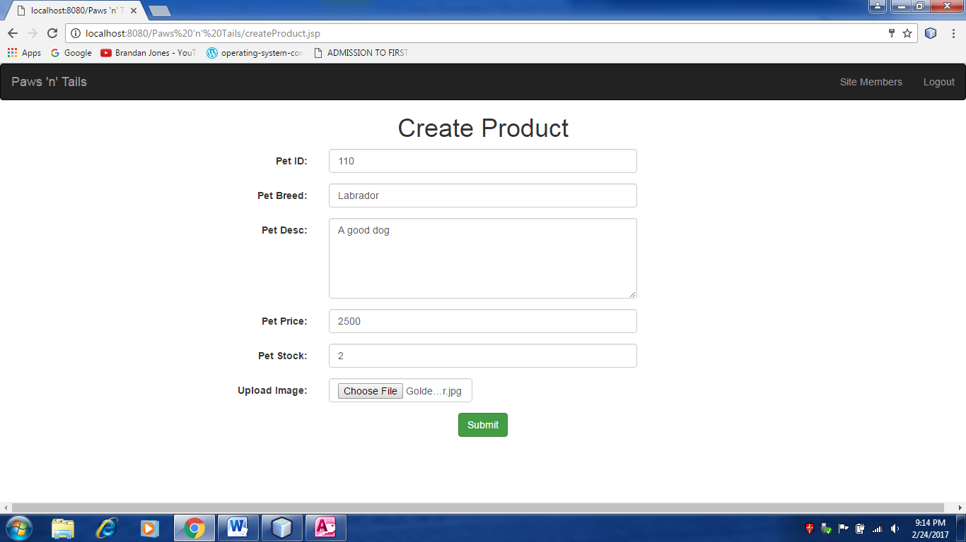

**Services:**

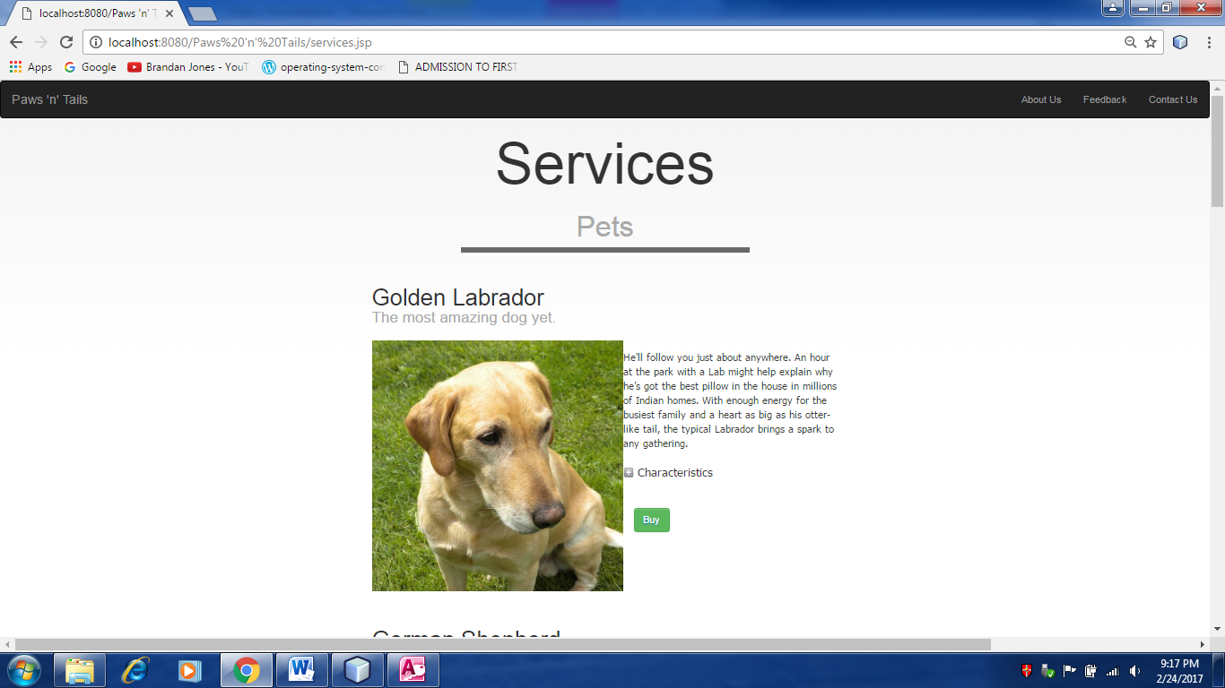

**CreateAccessory**

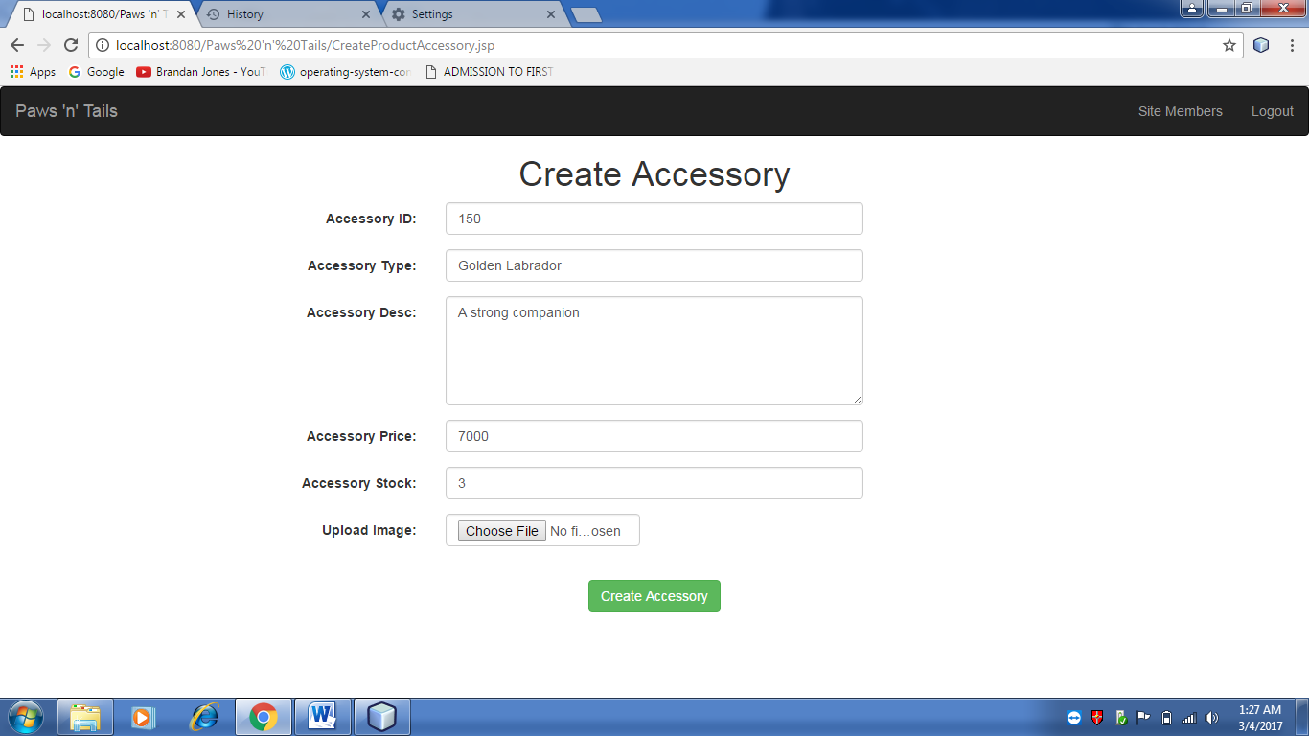

**FeedbackList**

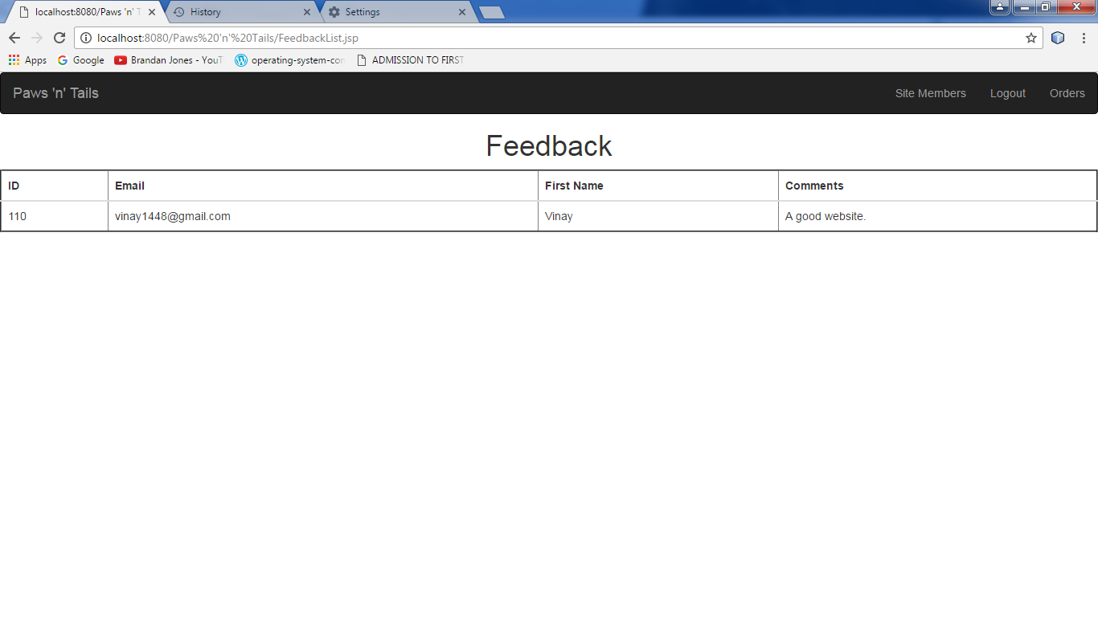

**PetList**

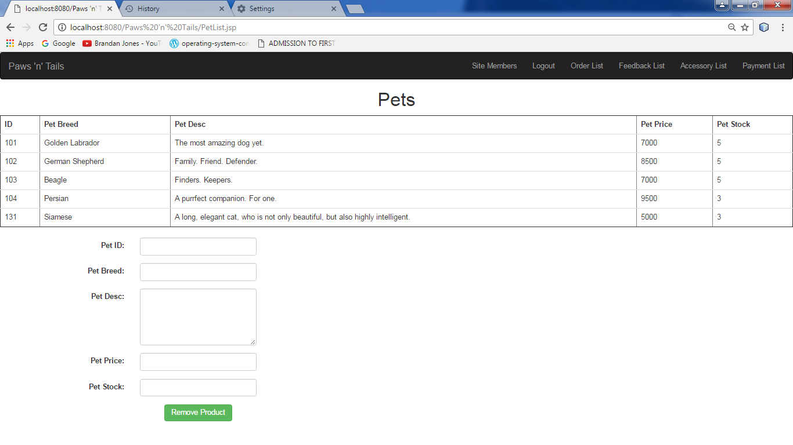

**AccessoryList**

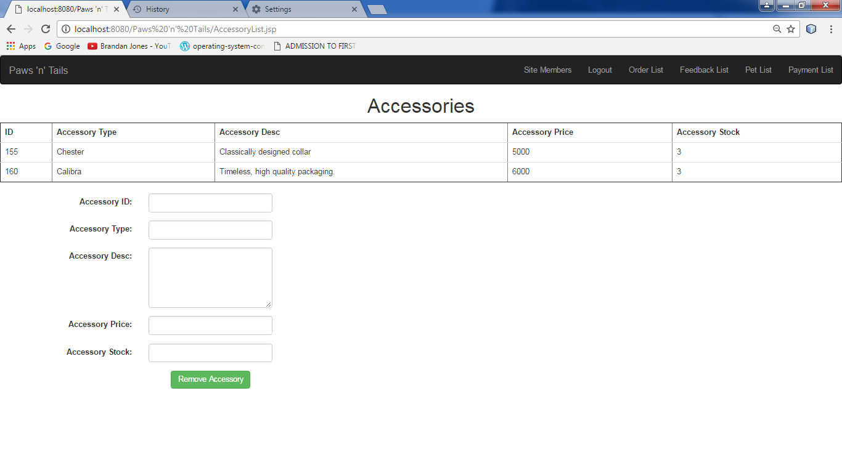

**PaymentList**

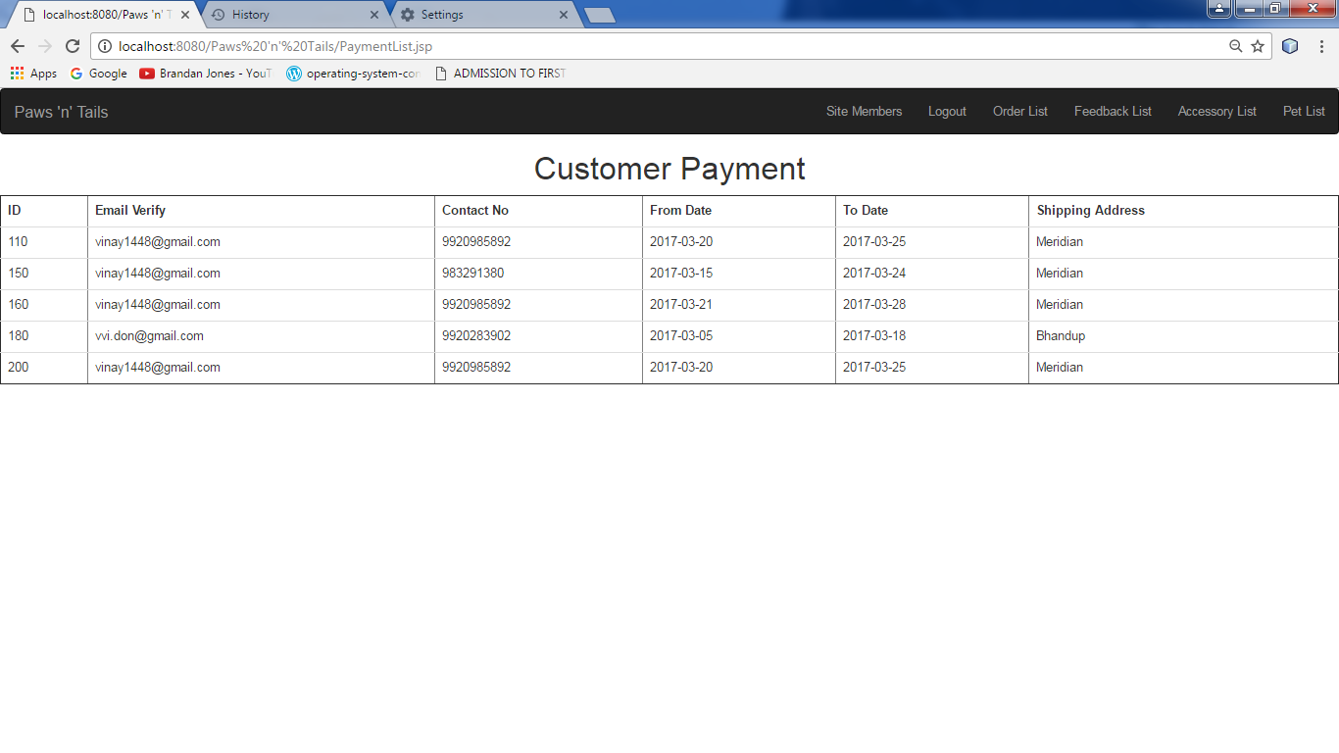

**Bill**

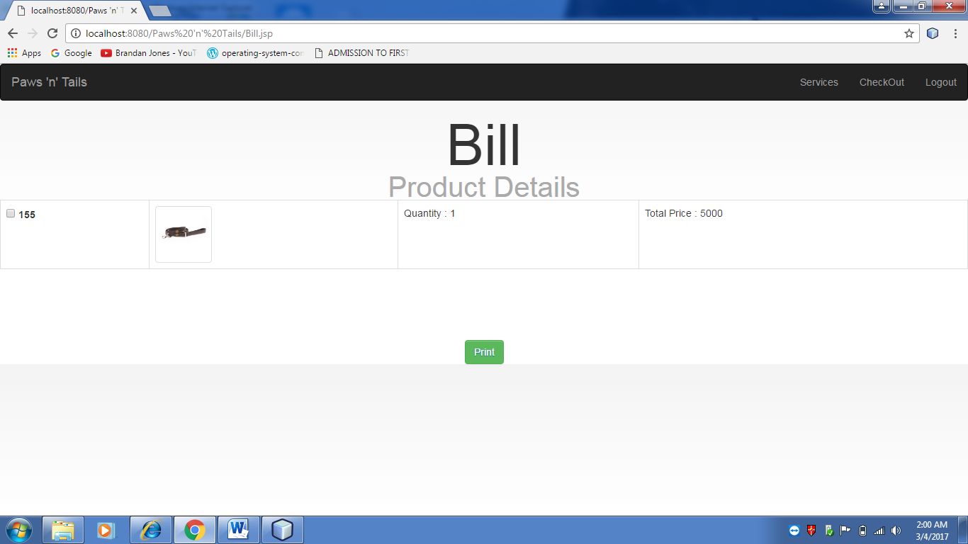

**PROGRAM LIST**

|  |  |
| --- | --- |
| **Form Name** | **Description** |
| 1. index.jsp | This is the home page of the web site. |
| 1. about.jsp | This page describes what the website is about. |
| 1. Contact.jsp | This page displays the website’s contact information for a query. |
| 1. Feedback.jsp | This page allows users to add some feedback to the website. |
| 1. Registration.jsp | This form allows users to register into the website. |
| 1. login.jsp | This form is for the users to logon to the website. |
| 1. passwordforgot.jsp | This page allows users to change the current password. |
| 8. Services.jsp | This page is for users to view the displayed products. |
| 1. AdminConsole.jsp | This is the homepage of admin after successful login. |
| 10. Bill.jsp | This page displays the customer’s current bill. |
| 11. Checkout.jsp | This form is for users to perform payment after selecting a product. |
| 12. ShoppingCart.jsp | This page is for users to view their products added to the cart |
| 13. admin.jsp | This form is for users to logon to the admin page |
| 14. log.jsp | This page provides the backend for users to logon to the home page. |

**Report List**

|  |  |
| --- | --- |
| 16. CreateProductAccessory.jsp | This page allows the admin to create an accessory of their choice. |
| 17. AccessoryList.jsp | This page allows admin to view created accessories. |
| 17. FeedbackList.jsp | This page allows the admin to view the feedback reports. |
| 18. OrderDetails.jsp | This page allows the admin to view the order details made. |
| 19. OrderList.jsp | This page allows the admin to view the various orders made by the customer. |
| 20. PaymentList.jsp | This page allows the admin to view the payment reports made by the customer. |
| 21. PetList.jsp | This page allows the admin to view the pet reports created/added to the Page of Products. |
| 22. ProductList.jsp | This page allows the admin to view the pets the customer can add to cart. |
| 23. ProductListAccessories.jsp | This page allows the admin to view the accessories the customer can add to cart. |
| 24. createProduct.jsp | This form allows the admin to add a product to the Page of Products. |
| 25. AdminLoginBack.jsp | This page contains the backend for the admin to logon successfully to the admin page. |

**SYSTEM IMPLEMENTATIONS/**

**UPLOADING**

Once the user has completed with the coding the application, and tested on

multiple machines, it is ready to be deployed.

The implementation process contains software preparation and transition activities, such as the conception and creation of the maintenance preparation for handling problems.

In order to deploy any application, it was first hosted on IIS server and tested on

different browsers.

**FUTURE ENHANCEMENTS**

However prefect a website may seem to, be, there is always scope for improvement. This Paws ‘n’ Tails Online Website in no exception.

The following are the possible enhancement to the new Website.

Some of the enhancements can be as follows:

1. New Modules can be added to make website more flexible.
2. The online confirmations can be added with Services.
3. The system can be made web enable to facilitate some of the transaction between organization and the customer.
4. Through future needs can’t be predicted, they will be added and improved over the course of time.

**References and Bibliography**

**Reference Books:**

* **System Analysis, Design - Written by S. Parthasarthy**
* **Introduction to Software Engineering - Written by S. Parthasarthy**
* **System Analysis and Design - Written by Sain James**
* **Software Engineering - Written by Roger Pressman**
* **Software Engineering - Written by Pankaj Jalote**
* **Project Management - Written by K.R.Sharma**

**Reference Websites :**

* [**www.google.com**](http://www.google.com)
* [**www.clgprojects.in**](http://www.clgprojects.in)
* [**www.stackoverflow.com**](http://www.stackoverflow.com)
* **www.w3schools.com**

|  |
| --- |
|  |